Lesson 163 & 164

Working With The Local Config File

<https://www.canva.com/en_gb/login/?redirect=%2Fdesign%2FDAEV-h9bSG4%2FR6FyldDe8CO8Wfn8z92yRA%2Fview>

<https://git-scm.com/docs/git-config>

The first 2 above is the remote that I get when cloned the project



I set the local branch to cyan

Changed the color of the diff which is differences btw one branch and another

Lesson 165

Inside Git: The Refs Directory

You will see this if you have atleast one commit and one branch.

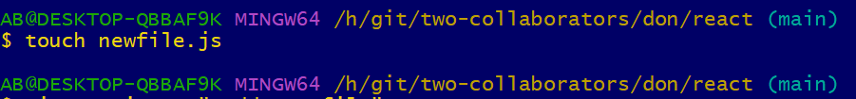

Once you commit it changes to the new commit head

I also have a tag folder

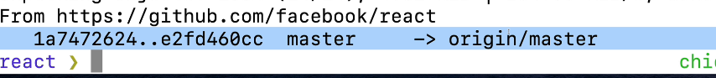

Lesson 166

Inside Git: The HEAD file

Lesson 167

Inside Git: The Objects Directory

It store all the git history file. It store the snap shot

Lesson 168

A crash Course On Hashing Functions

<https://linkgod.github.io/SHA-1/>

Lesson 169

Git As Key-Value On Hashing

Lesson 170

Hashing With Git Hash-Object

<https://git-scm.com/docs/git-hash-object>

Echo and hash the result using hash-object using –stdin

No matter how many times I hash it will always get the same hash number

I will open the .git directory

Object still does not have nothing.

Use more option -w meaning for write and store it

The hashing start with ce

The file will contain our data in my dig database.

Lesson 171

Retrieving Data With Git Cat-File

https://git-scm.com/docs/git-cat-file

Now I want to get the information out

I will delete the content of the file now

Restored back

Lesson 172

Deep Dive Into Git Objects: Blobs

Blob is used to store the content of a file.

They have a blob hash not commit hash.

Lesson 173

Deep Dive Into Git Objects: Tree

Blob store the content of a file

If I have a file inside a folder, that is called a tree and it will point to a blob

485635968b158b436200c9864671b449d7eaeadc

You can see the content of the read me.

Tree represent a folder

Lesson 174

Deep Dive into Git Objects: Commits

I will copy this hash

Want to make 2nd commit

